Front End Development + DevOps
- Javascript
- Modern Javascript (ES6+)
- Typescript
- React.js
- Docker
- Kubernetes
HTML (Hyper Text Markup Language): It is to develop contents for the web pages
CSS (Cascading Style Sheet): It is to style the HTML elements
Javascript: It is to add dynamic behavior for HTML & CSS
HTML elements
h1, h2, h3, h4, h5, h6, p, a, ol, ul, button, form, input, table
CSS
There are 3 ways you can apply CSS
- Inline CSS - within HTML element
- Internal CSS - within HTML document
- External CSS - with external CSS
Inline CSS
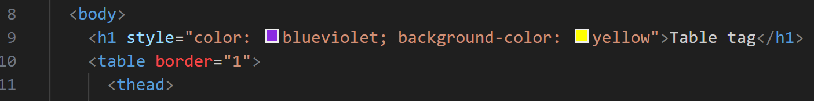
Internal CSS
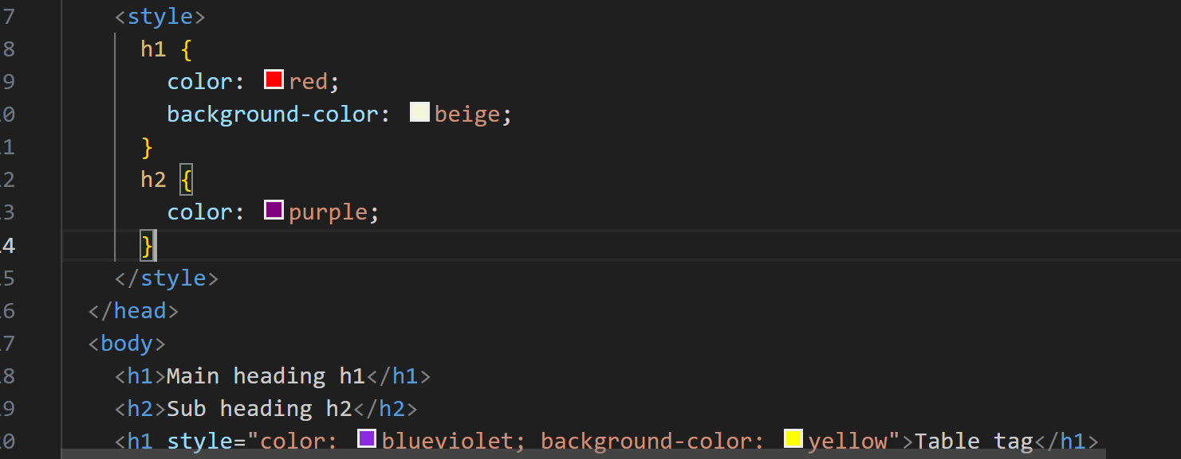
main.css
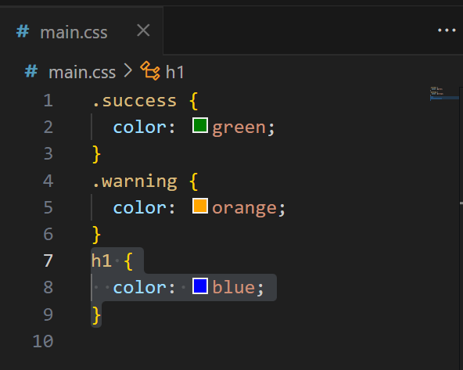
index.html
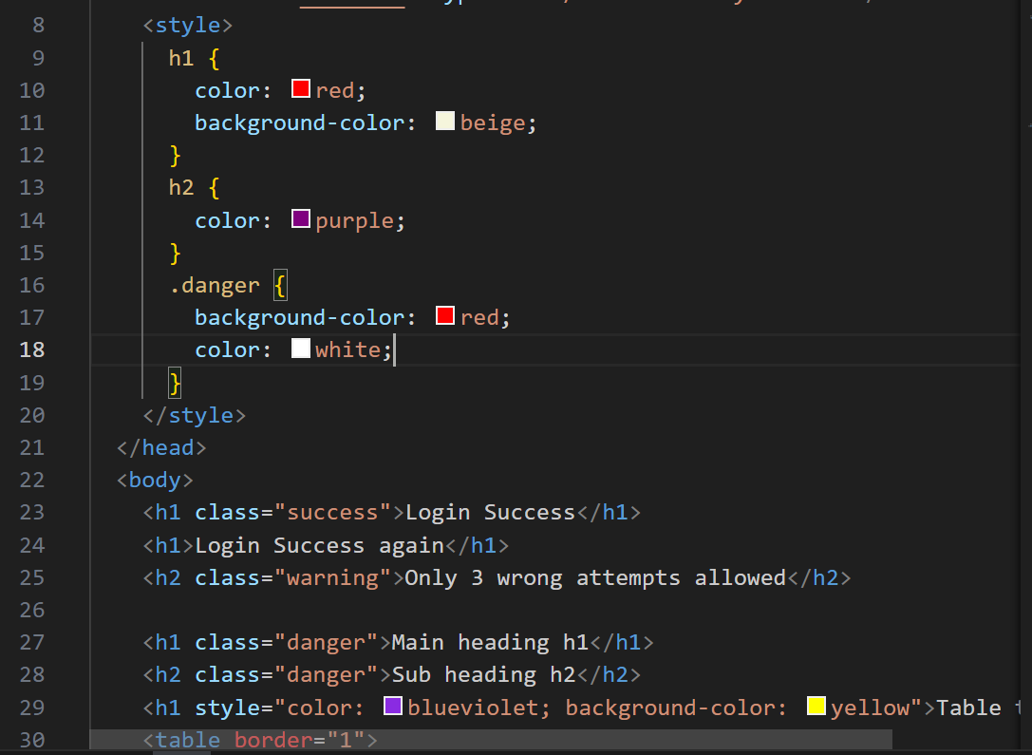
Output:
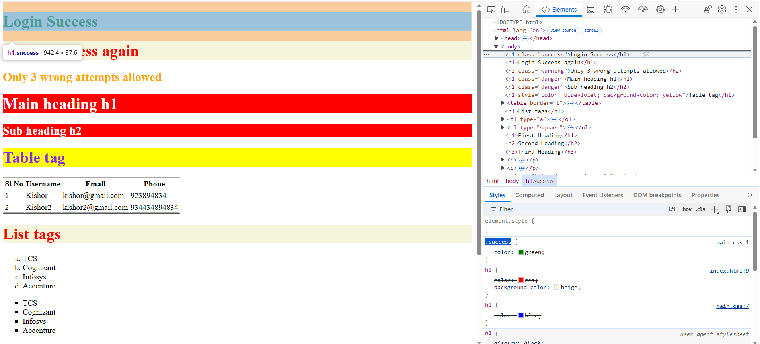
HTML Forms:
These allow user to enter inputs, you can create textbox, password box, radio, date, buttons, checkbox, drop down items, email box, number box
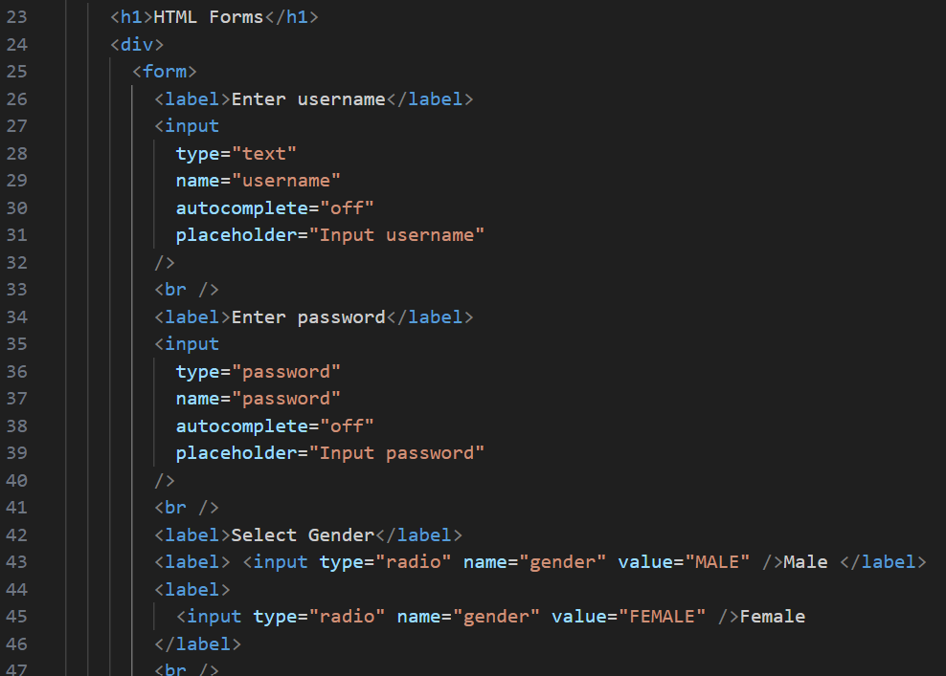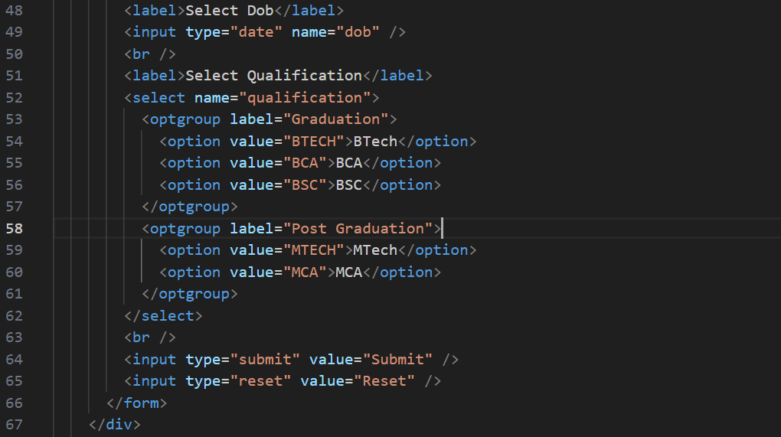

Javascript:
It is a programming language to access HTML & CSS at runtime and add dynamic behavior to your website, these days with the help of Node.js you can use Javascript to create backend services like RESTAPI’s, accessing backend database.
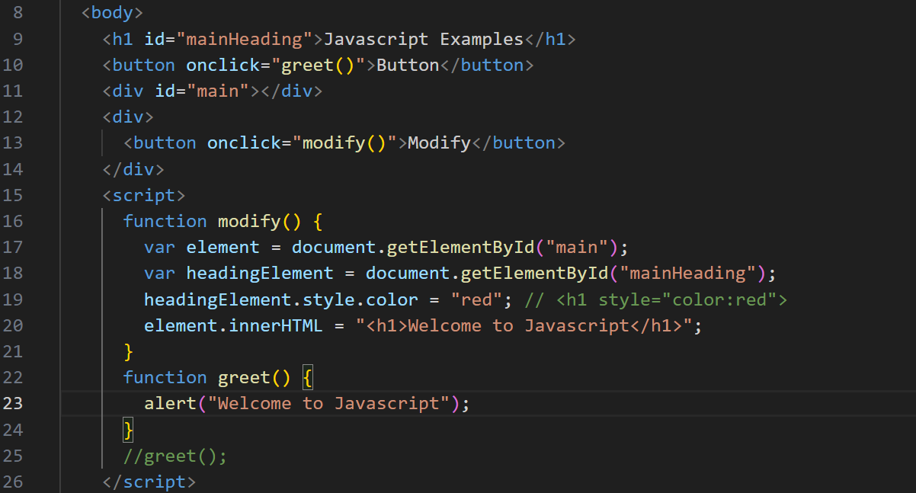

Using events to identify the elements instead of id
<div onclick=”roll(event)”>
<img src=”URL” >
<img src=”URL” >
<img src=”URL” >
</div>
roll(eve) {
var ele = eve.target;
}
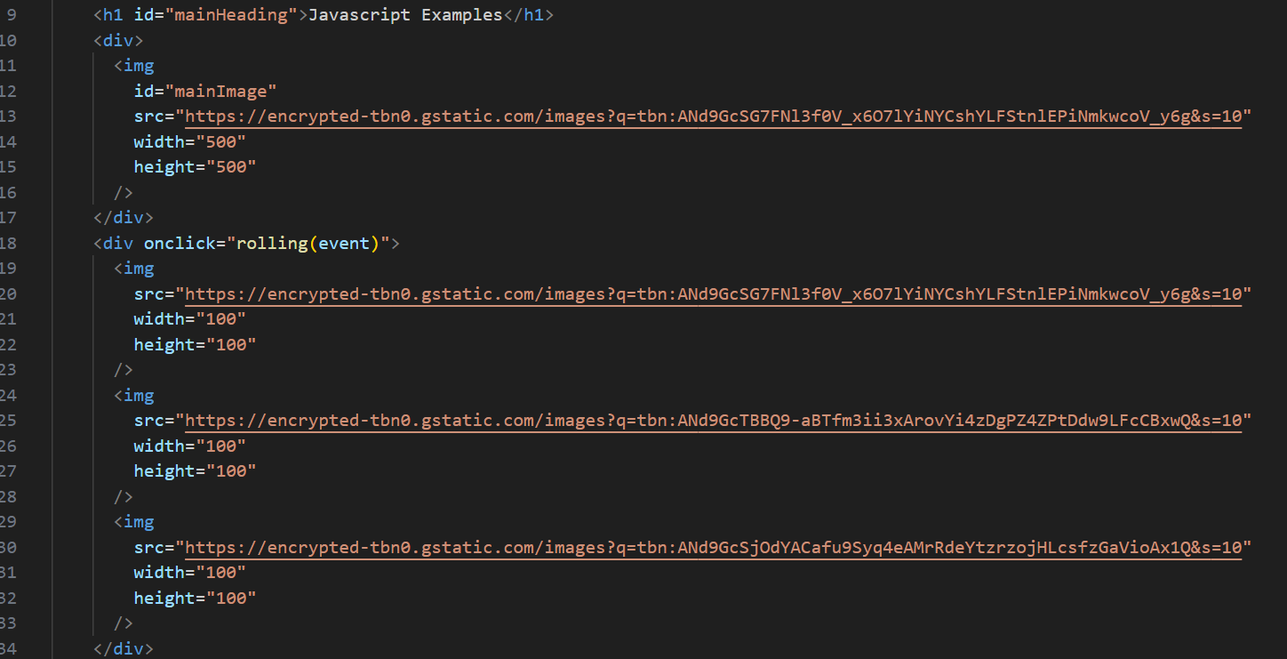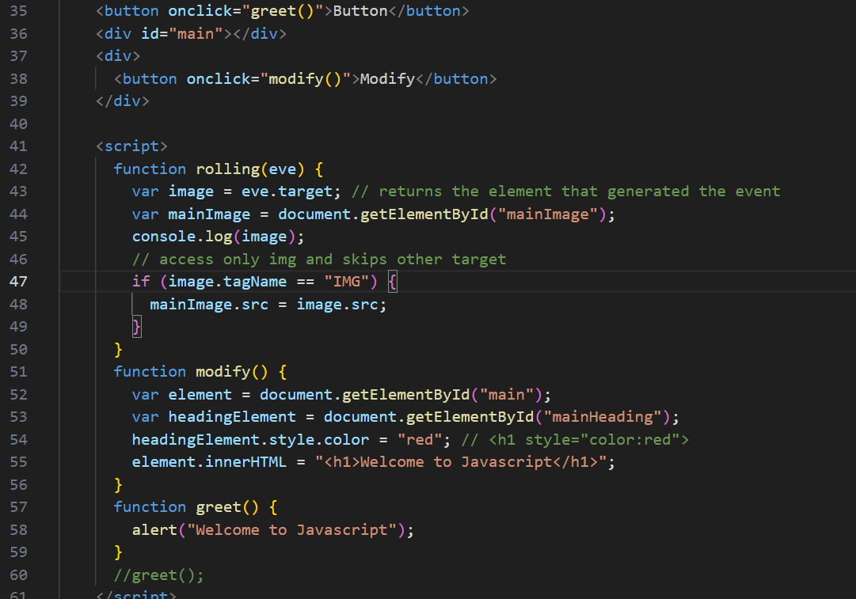
Output:
